# Copy Path in Right Click Menu

**Create a “Copy Path” Service for the Right-Click Menu**

If you find yourself frequently needing to copy and paste file and folder paths, creating an Automator Service will make your life easier because the service then becomes accessible from the OS X Right-Click contextual menu, accessible from anywhere in the Finder. This is an excellent trick from [**CNet**](http://reviews.cnet.com/8301-13727_7-57578129-263/how-to-copy-a-file-path-in-os-x/) and is very easy to set up yourself:

* Launch Automator and create a new “Service”
* Use the search function to look for “Copy to Clipboard” and drag that into the rightside panel of the Service
* Set ‘Service recieves selected’ to “files or folders” and ‘in’ to “Finder” as shown in the screen shot below
* Save the Service with a name like “Copy Path”

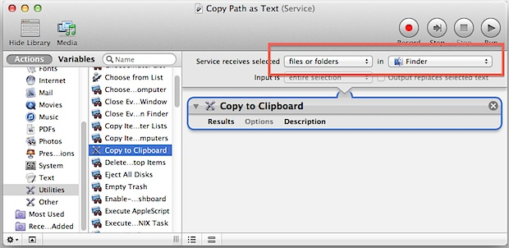

Now go anywhere in the Finder, select anything in the filesystem be it a directory or a file, then right-click to reveal the “Copy Path” service item as created.

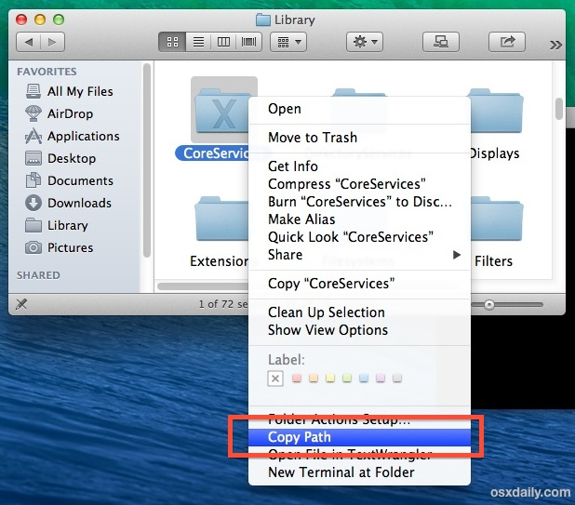

* Choosing that option will instantly copy the chosen items path to the clipboard, which you can then paste elsewhere.